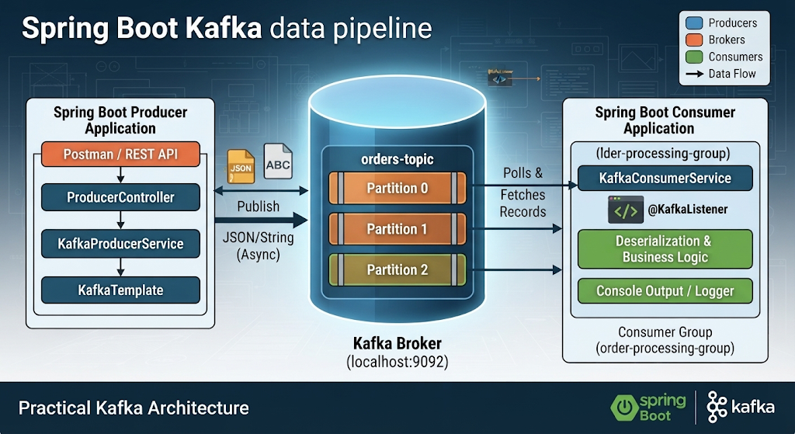

1. Spring Boot Producer Application (Left)
This block represents the entry point where messages are created and sent to the Kafka ecosystem.

- Postman / REST API: The external client interface used to trigger HTTP requests (like sending JSON orders or raw strings) to your application.

- ProducerController: The REST controller layer (ProducerController.java) that maps incoming HTTP requests and passes the payload to the service layer.

- KafkaProducerService: The business logic service (KafkaProducerService.java) that prepares the messages for dispatch.

- KafkaTemplate: Spring Kafka’s core helper utility that handles the actual serialization and asynchronous network calls to push records to the broker.

2. Kafka Broker (Center)
The core infrastructure layer running locally that receives, stores, and distributes data streams.

- orders-topic: The logical channel or category where all order-related messages are published.

- Partitions (Partition 0, Partition 1, Partition 2): The physical subdivisions of the topic. Splitting the topic into multiple partitions allows for parallel processing and ensures that messages with keys (like orderId) are routed deterministically.

3. Spring Boot Consumer Application (Right)
This block represents the processing side that continuously reads, parses, and handles the data coming out of Kafka.

- order-processing-group: The Consumer Group name. It ensures that the partitions are distributed across consumer instances so that each partition is consumed by only one worker at a time, avoiding duplicate processing.

- KafkaConsumerService: The application service responsible for receiving the data stream.

- @KafkaListener: The Spring annotation that registers the method to automatically poll and listen to the specified topic.

- Deserialization & Business Logic: The internal handling where raw JSON data is converted back into objects (like OrderEvent) or strings, followed by executing application logic (such as validation or data processing).

- Console Output / Logger: The final destination where the processed message details are printed out to your terminal logs.

4. Data Flow (Arrows)
- Publish (JSON/String): Shows data leaving the producer asynchronously and writing into the broker's partitioned storage.

- Polls & Fetches Records: Represents the consumer group's continuous background loop (poll()) pulling batches of records from the partitions down into the consumer application for handling.

